  Bert Hertogen  Meiselaan 24 bert@hertogen.net  1880 Nieuwenrode www.linkedin.com/in/bert-hertogen  0486 02 95 48 bert.hertogen.net  Born at Hasselt on 18 May 1986  Work Experience  2022 – now: Developer at ADB Safegate  - We are tasked with creating the datapipeline for numerous IoT data (eg: metrics for lights, ...) of an airfield. Streaming this data into Databricks and provide endpoints for new and existing applications to ingest this data.  - We extracted shared components into a shared application platform to maximize reusability inside the organization (eg: authentication, master data services, ...).  Technology: Terraform, Azure DevOps, Databricks, Python  2020 – 2022: Developer at Ferm  - As one of the lead developers on the KOAla project I implemented new features, setup and maintained the CI/CD pipeline and environments in Azure and optimized and automate the local development environments for all developers.  Technology: ASP.NET, Angular, Entity Framework, Azure DevOps  2018 – 2020: Developer at Belfius  - I was tasked with creating additional features for existing web applications, combined into a large monolith. To make our CI/CD flow less error prone we sliced the monolithic application, backed by a monolithic framework, into smaller modules.  - I maintained and added services to the Belfius.be Tridion CMS to supply this content to other teams.  - I updated the frontend for the Knowledge Database (KDB) application Angular one feature at a time.  Technology: ASP.NET, AngularJS, Angular, Oracle, Entity Framework  2015 – 2018: Developer at Ferm (https://www.samenferm.be/)  - Together with the business we created an online shop for Ferm.  - We created a platform where caregivers can manage their planning and details of their caretakers.  - Update the technology stack for online reservation system for daycare.  These applications were created as Angular apps backed by rest services.  Technology: ASP.NET, AngularJS, Angular, NgRx, MSSQL  2012 – 2015: Developer at Boerenbond  - They needed an application to manage their members and authenticate these members in several systems. This ASP.NET Mvc application allowed registered members to manage their profile online.  - A separate application, an implementation of ADFS, handled authentication of these members for several internal and external systems.  Technology: ASP.NET, MSSQL, ADFS  2007 – 2012: Developer at Cegeka  - I implemented the DotNetNuke cms for several clients. More advanced features, not covered by the available modules, were covered by custom modules. Some examples of these advanced features are a store locator, sharepoint integration, a webshop.  Technology: DotNetNuke, ASP.NET, MSSQL | 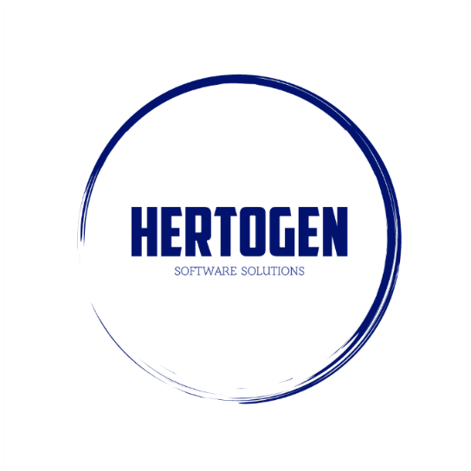  Skills & talents  Languages:  Dutch: mother tongue  English: very good  French: basic  Problem-solving:  I can get to the root of problems and isolate them fast and provide a range of possible solutions.  Eager to learn:  I am always on the lookout for new challenges and technologies. Be it professional or private projects.  Flexible:  I have no problem supporting colleagues whenever needed and stepping in for someone.  Team player:  I like being part of a team, bounce ideas and strategies around, discuss plans and approaches with colleagues.  Education & Training  2017: Angular & Rxjs advanced (ng-be)  2016: Rxjs course (Strongbrew)  2016: Angular couse (Toughtram)  2009: MCTS .net 2.0 web & fundementals  2004 – 2007: Bachelor of Information Technology at XIOS  Knowledge  Angular  ASP.NET  .NET Core  TSQL  Azure Services

